Mini EDA Report: Employee Dataset Analysis
Prepared by: Shubhangi Khonde
Tools used: Python, Pandas, Matplotlib, Seaborn (Jupyter Notebook in VS Code)
Task: Task 14, Exploratory Data Analysis (cleaning, summary statistics, visualizations)

1. Introduction
Exploratory Data Analysis (EDA) is the process of examining a dataset to understand its structure, fix data quality problems, and find patterns before any deeper analysis. This report presents a mini EDA of a company’s active employee dataset, using Pandas for data handling and Matplotlib/Seaborn for visualization.
2. Dataset Description
The dataset contains records of 800 employees and 14 columns, loaded from Active_Employees.csv.
Type | Columns
Identifier | Employee_ID, Employee_Name
Categorical | Gender, Department, Job_Title, City, State, Employment_Status, Grade
Numeric | Age, Salary, Performance_Score, Bonus
Date | Joining_Date
The data covers 7 departments (Sales, HR, IT, Operations, Marketing, Finance, Customer Support), 6 states, and 4 performance grades (A to D).
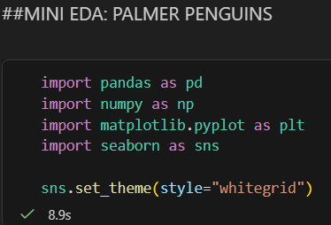
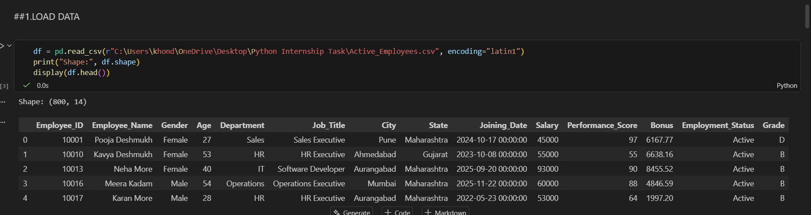

3. Initial Data Inspection
The following checks were performed on the raw data:
- df.shape, df.info() and df.describe() to understand size, data types and ranges
- df.isnull().sum() to check missing values
- df.duplicated().sum() to check duplicate records
- unique() on categorical columns to check for inconsistent spellings
Findings: There were no missing values and no duplicate rows. Numeric ranges were realistic (Age 21 to 55, Salary 25,000 to 95,000, Performance Score 50 to 100). The Joining_Date column was stored as text instead of a date type.

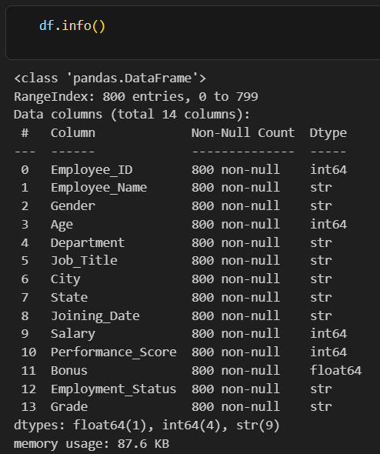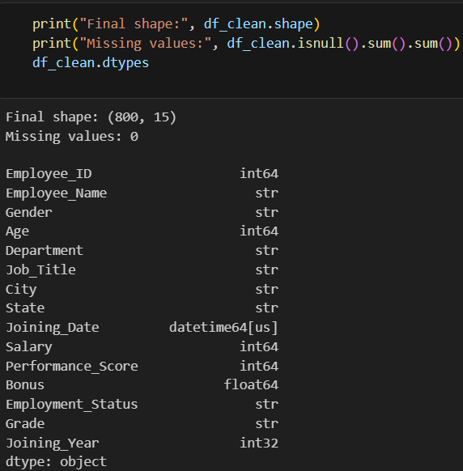

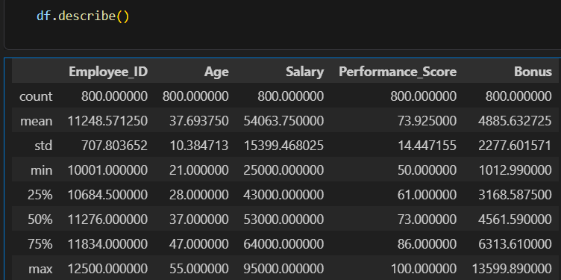

4. Data Cleaning
Step | Action | Reason
1 | Created a copy of the data (df_clean) | To keep the original data safe
2 | Converted Joining_Date to datetime and created a Joining_Year column | Enables date-based analysis
3 | Removed leading/trailing spaces in text columns | Prevents the same value being counted as different categories
4 | Checked and removed duplicates (by full row and by Employee_ID) | 0 duplicates found, so no rows were removed
5 | Checked categorical values | Values were consistent (Male/Female, A/B/C/D)
6 | Checked outliers using the IQR method | Age, Salary, Performance_Score: 0 outliers. Bonus: 8 outliers
7 | Kept the Bonus outliers | They are genuine high bonus values, not data errors

Missing values: none were found, so no imputation was needed.
Note: Employment_Status contains only “Active”, so it carries no analytical value and was not used in the charts.
Final cleaned dataset: 800 rows and 15 columns (including the new Joining_Year), with 0 missing values.
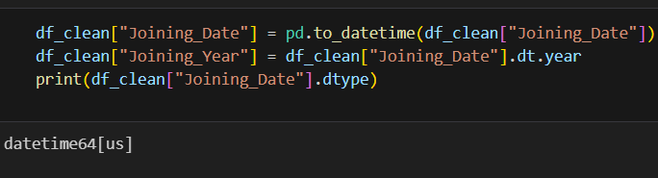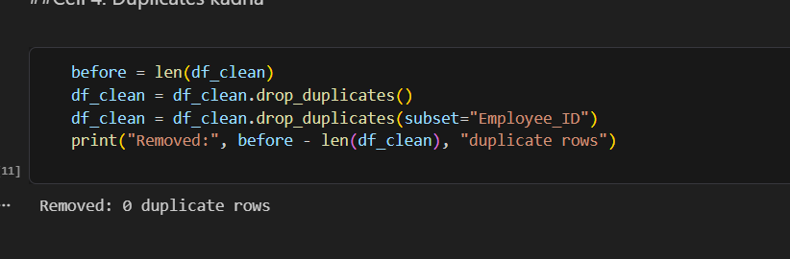
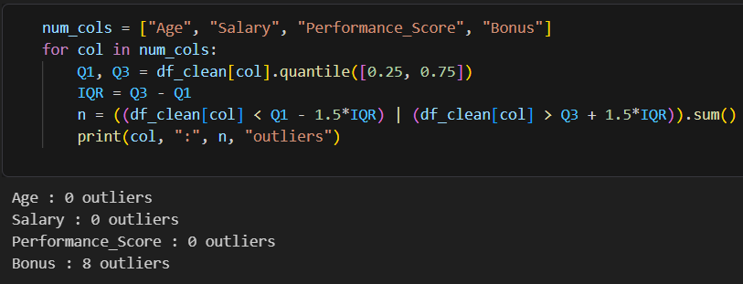
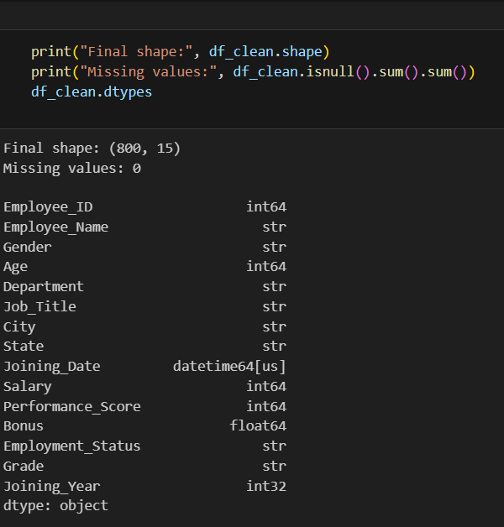

5. Summary Statistics
Metric | Mean | Min | Max
Age | 37.69 years | 21 | 55
Salary | 54,064 | 25,000 | 95,000
Performance Score | 73.9 | 50 | 100
Bonus | 4,886 | 1,013 | 13,600
Grouped analysis:
- Marketing has the most employees (127).
- Average salary by department: IT is highest (71,858) and Customer Support is lowest (41,231).
- Average salary by gender: Female 54,403 and Male 53,690.
- Average salary by grade: A 52,412, B 53,335, C 57,503, D 53,247.

6. Visualizations
Chart 1: Distribution of Salary (Histogram). Shows how salaries are spread across the 25,000 to 95,000 range. [Add one line: where most employees fall.]

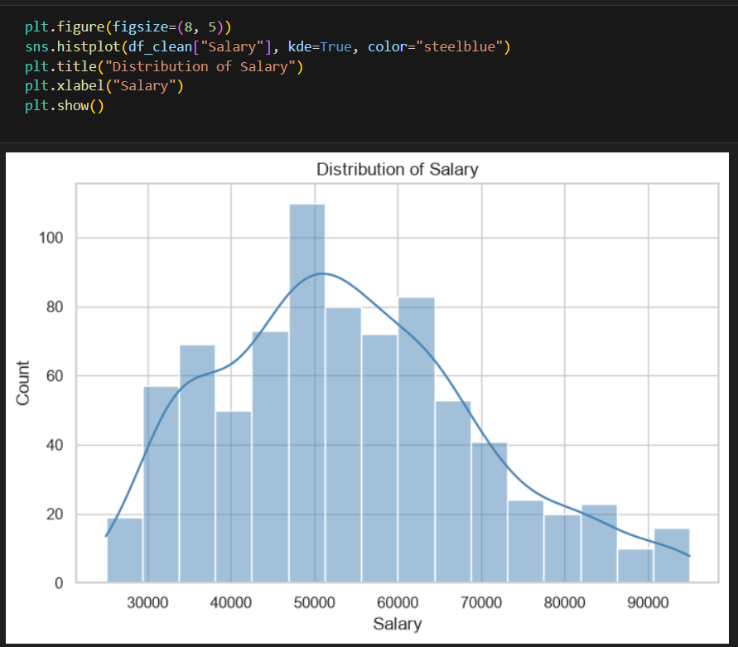

Chart 2: Employees by Department (Countplot). Compares headcount across the 7 departments. Marketing has the highest headcount.
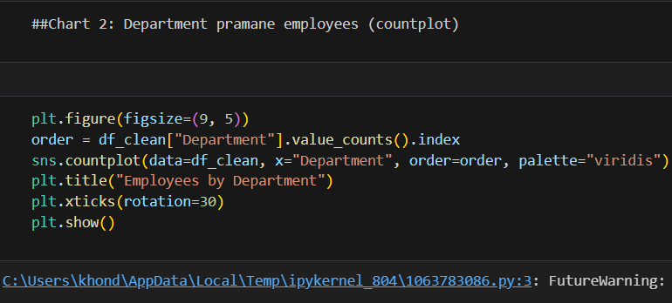

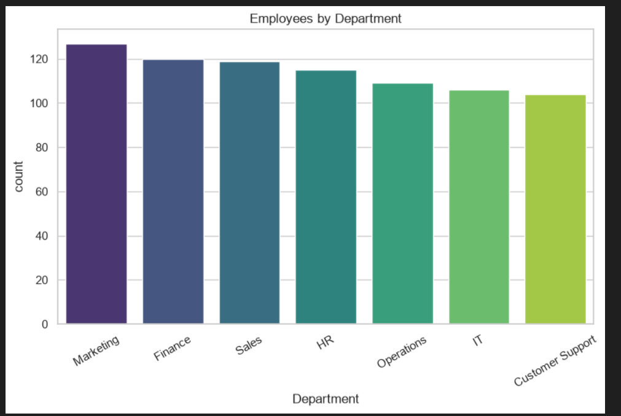

Chart 3: Salary by Department (Boxplot). Shows salary spread and median for each department. IT has the highest salaries and Customer Support the lowest.
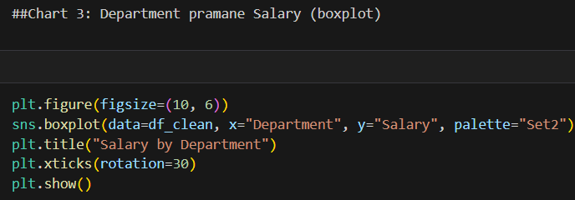

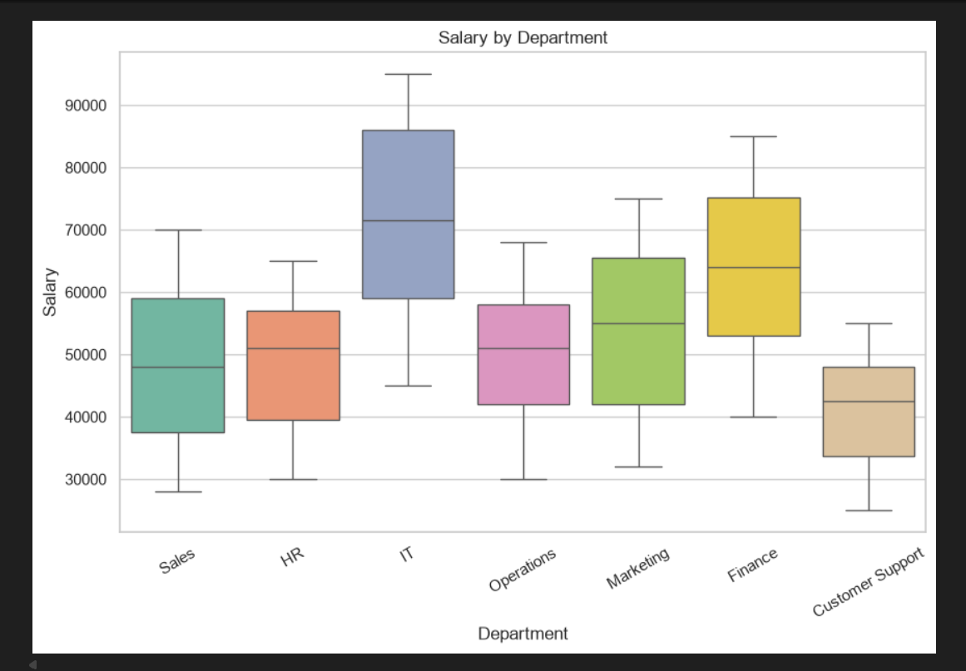
Chart 4: Correlation Heatmap. Shows relationships between Age, Salary, Performance Score and Bonus. The strongest relationship is between Salary and Bonus (0.56), a moderate positive correlation.
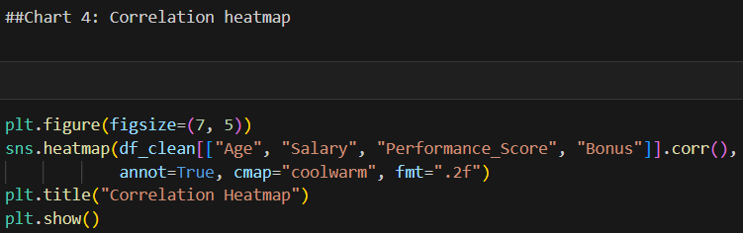
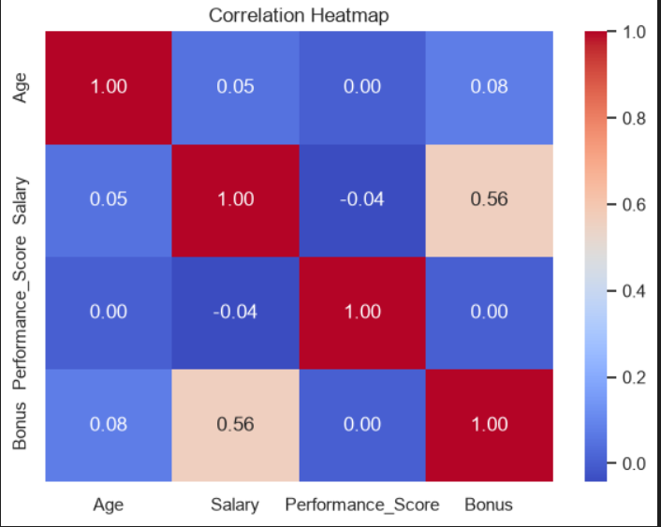
7. Key Insights
- Department is the main driver of salary. IT earns about 30,000 more on average than Customer Support.
- Gender pay difference is very small (about 700 between averages), so no major gender-based gap appears in this data.
- Grade does not clearly relate to salary. Grade C has the highest average salary, and Grade A the lowest, which is unusual and worth a closer look.
- Salary and Bonus are moderately correlated (0.56), so higher-paid employees tend to receive higher bonuses.
- 2024 was the year with the most new joiners.
- Data quality was good. There were no missing values or duplicates.

8. Conclusion
This mini EDA examined 800 employee records. After checking and cleaning the data, summary statistics and four visualizations were used to understand the workforce. The analysis shows that salary depends mainly on department rather than gender or grade, and that salary and bonus are moderately related. These findings can help the company review its salary structure, plan hiring, and study how grades are assigned.

